

CBOE Financial Network

Network Specification

Version 2.1

Oct. 16, 2003

Network Design
The CFN uses IP multicast to efficiently and equitably distribute market data to all connected Firms simultaneously. All transmissions from the CFN to Firms are unsolicited and non-interactive. Multicast routing protocols and IGMP are not required to receive IP multicast traffic from the CFN but may be required within the Firm network. ICMP (Ping) for network management and troubleshooting is the only traffic Firms are permitted to send into the CFN.
The CFN is designed as two completely independent networks, i.e. CFN A and CFN B. Identical data in different multicast groups is transmitted to both networks. As there is no fail-over between the two networks, for redundancy, Firms must connect to and read the data from both networks.
A diagram of the CFN WAN is shown in Figure 1. With the CFN WAN, the two networks may be provisioned at a single Firm site or to two different sites, e.g. a production site and a disaster recovery site.
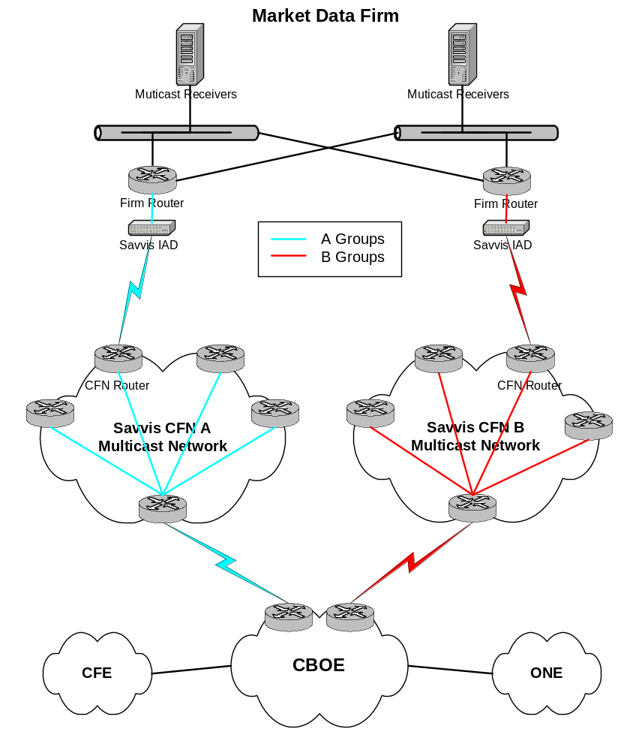
Figure 1. Savvis CFN WAN
CBOE has acquired the services of Savvis for the CFN WAN. The Savvis network uses ATM transport between IP multicast routers to provide the required service levels. Firm connections to the CFN WAN are via one or more T1s using IMA or fractional DS-3 depending on the required bandwidth.
The circuits are terminated in Integrated Access Devices (IADs) which are managed by Savvis. The IADs do translational bridging between ATM on the access circuit(s) and a 10baseT Ethernet (half duplex) or 100baseT full duplex Firm interface. Since the IADs are bridges, it is imperative that these are not connected to network segments with high levels of broadcast or multicast traffic. It is recommended that the IADs be directly connected to a Firm router. Alternatively, they may be connected to a dedicated switch (VLAN) with the Firm multicast receiver host(s).
Firms are required to provide registered IP addresses for the network segments connected to the CFN routers (Savvis IADs). One address will be assigned to the CFN router and the others to the Firm router or host(s). Registered IP addresses may be obtained from the American Registry for Internet Numbers (ARIN). Alternatively, CBOE will assign private IP addresses, in consultation with the Firm. Please note, it is the Firm’s responsibility to avoid any IP address conflicts within their network.
CBOE monitors the status of the CFN by pinging the edge firm router or a host connected to the IAD Ethernet segment. To respond to CBOE pings, the firm router or host must have a static route to the CBOE management network, 170.137.7.0/24, with the CFN router as the next hop. If the Firm is using routers, they may need to add static routes for the multicast source networks for the Reverse Path Check. The required source networks are listed in Table 1. The next hop for these routes is the CFN router.
Table 1. Multicast Source Networks
Data Channel | Groups | Source Network
CFE CQ/LS | A | 170.137.92.0/24
CFE CQ/LS | B | 170.137.91.0/24
CFE BD | A | 170.137.13.96/28
CFE BD | B | 170.137.13.112/28
ONE CQ/LS | A | 170.137.92.0/24
ONE CQ/LS | B | 170.137.91.0/24
ONE BD | A | 170.137.13.96/28
ONE BD | B | 170.137.13.112/28
Data channel information
For each Data Channel, identical data is transmitted to two sets of multicast groups, i.e. A Groups and B Groups, with unique multicast group IP addresses and UDP port numbers. Bandwidth has been allocated to each Data Channel taking into consideration historical peak utilization and future growth. The present Data Channels are listed in Table 2. Additional Data Channels may be added to the CFN in the future.

 |  | A Groups |  | B Groups
Data Channel | Bandwidth  Allocation | Multicast IP Address | UDP  Port | Multicast IP Address | UDP  Port
ONE CQ/LS | 300 Kbps | 233.65.120.1 | 52101 | 233.65.120.2 | 52102
ONE BD | 1.0 Mbps | 233.65.120.3 | 52103 | 233.65.120.4 | 52104
ONE BD | 1.0 Mbps | 233.65.120.5 | 52105 | 233.65.120.6 | 52106
ONE BD | 1.0 Mbps | 233.65.120.7 | 52107 | 233.65.120.8 | 52108
CFE CQ/LS | 32 Kbps | 233.65.120.16 | 52116 | 233.65.120.17 | 52117
CFE BD | 64 Kbps | 233.65.120.18 | 52118 | 233.65.120.19 | 52119
CFE BD | 64 Kbps | 233.65.120.20 | 52120 | 233.65.120.21 | 52121
CFE BD | 64 Kbps | 233.65.120.22 | 52122 | 233.65.120.23 | 52123
Table 2. Data Channel Group Information

DATA FORMATS
The CFN does not process the market data or modify the data formats in any way. For information on the specific data formats please see these documents:
- CFE CQ/LS CFN/CFE Vendor Interface Specification
- CFE BD CFE Book Depth Vendor Specs V1.2
- ONE CQ/LS
http://www.onechicago.com/050000_techno_ops/images/OneChicagoDataSpec.PDF
- ONE BD ????????????????????

Contact information
To report a problem on an existing CFN connection, please call the CBOE Operations Department at 312-786-7642.
For all other inquiries, please call Peter Smith at 312-786-7681 or send an email to smithp@cboe.com.

CFN Connection Request Form

Requestor Information
Name: _________________________________________________
Title: _________________________________________________
Telephone: _________________________________________________
Cell Phone / Pager: _________________________________________________
E-Mail Address: _________________________________________________
Data Channels
_____ CFE CQ/LS _____ ONE CQ/LS
_____ CFE BD _____ ONE BD

Site Information (A Groups)
Circuit Installation Address
Street Address: ________________________________________________
City / State / Zip Code: ________________________________________________
Circuit Demarcation Location
Floor # / Closet # / Rack #: ________________________________________________
Site Contact Information
Name: ________________________________________________
Title: ________________________________________________
Telephone: ________________________________________________
Cell Phone / Pager: ________________________________________________
E-Mail Address: ________________________________________________
Intermediate Network IP Addresses
Registered IP Network and Mask: ________________________________________________
CFN Router IP Address: ________________________________________________
Firm Router or Host IP Address(es): ________________________________________________
(If you require CBOE to provide private IP addressing as described on page 3, please enter “Provided by CBOE”)

Site Information (B Groups)
Circuit Installation Address
Street Address: ________________________________________________
City / State / Zip Code: ________________________________________________
Circuit Demarcation Location
Floor # / Closet # / Rack #: ________________________________________________
Site Contact Information
Name: ________________________________________________
Title: ________________________________________________
Telephone: ________________________________________________
Cell Phone / Pager: ________________________________________________
E-Mail Address: ________________________________________________
Intermediate Network IP Addresses
Registered IP Network and Mask: ________________________________________________
CFN Router IP Address: ________________________________________________
Firm Router or Host IP Address(es): ________________________________________________
(If you require CBOE to provide private IP addressing as described on page 3, please enter “Provided by CBOE”)

